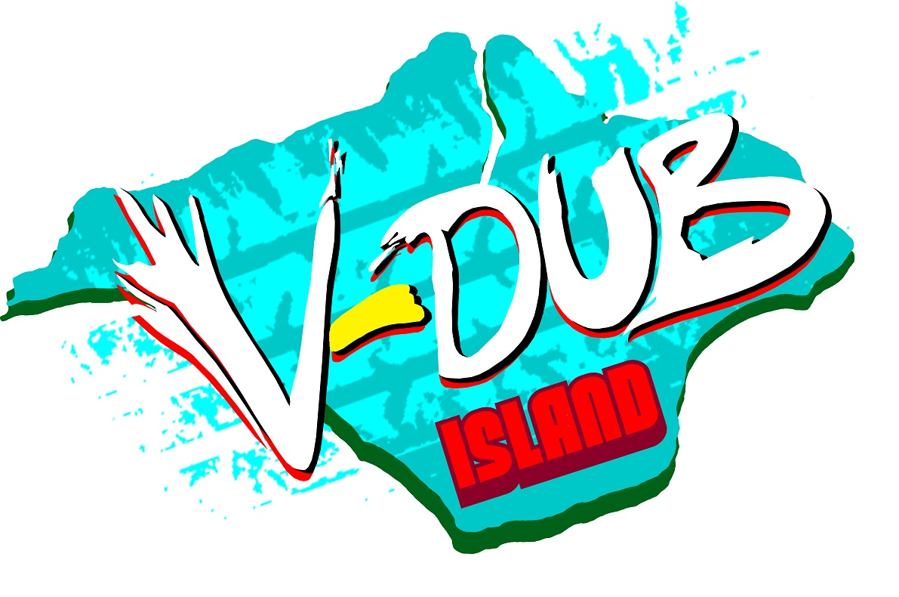

V-Dub Island
Electrical Hookup Request Form

Name:

Phone Number:

Email Address:

Postal Address:

Are you camping as part of a club? (Y/N) :
If Yes, please state which club:

Vehicle Registration Number(s):

Total number of hookups required:

We are currently arranging the areas for hookups on site depending on demand. Please complete this form to register and return it by email to hookup@v-dubisland.com .

Prices for 2012 are currently TBC depending on demand and the rising price of generator fuel.

